**Experiment 4**

**(React.js)**

**Name: Nishant Golakiya**

**Sap: 60009220150**

**Batch: D2-2**

**Aim:** Create an application using React.

**Lab Assignments to be done by students:**

1. Rendering single element

2. Rendering component having multiple element

3. Export and import user defined component

4. Import and use CSS in react application

5. Implement props in react application

6. Raising and event handling.

7. Use of react useState hook to increment and decrement value.

**Theory:**

React is a declarative, efficient, and flexible JavaScript library for building user interfaces. It lets user compose complex UIs from small and isolated pieces of code called “components”.

React has a few different kinds of components (React.Component), components are used to tell React what to see on the screen. When our data changes, React will efficiently update and re-render our components.

Example:

**index.html**

<div id="root"></div>

**index.js**

import React from "react";

import ReactDOM from "react-dom";

const element = <h1>Hello World</h1>;

ReactDOM.render(element, document.getElementById("root"));

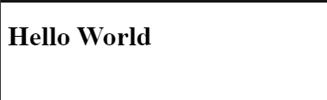

**React Components:**

Components are independent and reusable bits of code. They serve the same purpose as JavaScript functions, but work in isolation and return HTML.

Components come in two types, Class components and Function components.

Create a **Class component** called Car

class Car extends React.Component {

render() {

return <h2>Hi, I am a Car!</h2>;

}

}

**Function Component**

Here is the same example as above, but created using a Function component instead.

A Function component also returns HTML, and behaves much the same way as a Class component, but Function components can be written using much less code, are easier to understand, and will be preferred in this tutorial.

Example

Create a Function component called Car

function Car() {

return <h2>Hi, I am a Car!</h2>;

}

**Working with React Form and Handling Event**

Just like in HTML, React uses forms to allow users to interact with the web page.

Adding Forms in React: add a form with React like any other element:

Example:

Add a form that allows users to enter their name:

function MyForm() {

return (

<form>

<label>Enter your name:

<input type="text" />

</label>

</form>

)

}

const root = ReactDOM.createRoot(document.getElementById('root'));

root.render(<MyForm />);

**Raising and Handling Events**

Just like HTML DOM events, React can perform actions based on user events.

React has the same events as HTML: click, change, mouseover etc.

**Adding Events**

React events are written in camelCase syntax:

onClick instead of onclick.

React event handlers are written inside curly braces:

onClick={shoot} instead of onClick="shoot()".

React:

<button onClick={shoot}>Take the Shot!</button>

HTML:

<button onclick="shoot()">Take the Shot!</button>

Always import Hooks from react. Use the useState Hook to keep track of the application state. State generally refers to application data or properties that need to be tracked.

**Hook Rules**

There are 3 rules for hooks:

Hooks can only be called inside React function components.

Hooks can only be called at the top level of a component.

Hooks cannot be conditional

**React useState Hook**

The React useState Hook allows us to track state in a function component. State generally refers to data or properties that need to be tracking in an application.

import { useState } from "react";

**Initialize useState**

**I**nitialize our state by calling useState in our function component.

useState accepts an initial state and returns two values:

The current state.

A function that updates the state.

Initialize state at the top of the function component.

import { useState } from "react";

function FavoriteColor() {

const [color, setColor] = useState("");

}

1. **Code:**

import React from 'react';

import ReactDOM from 'react-dom';

const element = <h1>Hello, World!</h1>;

ReactDOM.render(element, document.getElementById('root'));

**Output:**

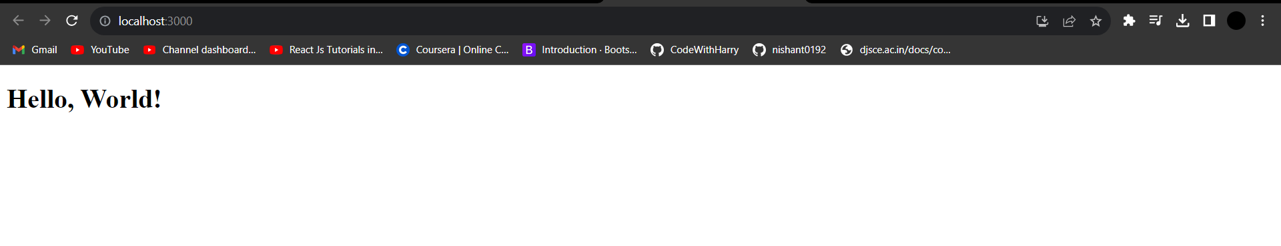

1. **Code:**

import './App.css';

import MyComponent from './MyComponent';

function App() {

  return (

    <div className="App">

      <MyComponent/>

    </div>

  );

}

export default App;

import React from 'react'

function MyComponent() {

  return (

    <div>

        <h1>Hello World</h1>

        <p>I am a Noob Coder</p>

    </div>

  )

}

export default MyComponent

**Output:**

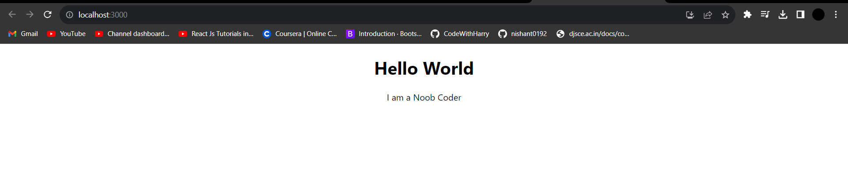

1. **Code:**

import './App.css';

import MyComponent from './MyComponent';

function App() {

  return (

    <div className="App">

        <MyComponent/>

    </div>

  );

}

export default App;

import React from 'react'

function MyComponent() {

  return (

    <div>

        <h1>Component has been exported and imported Successfully :)</h1>

    </div>

  )

}

export default MyComponent

**Output:**

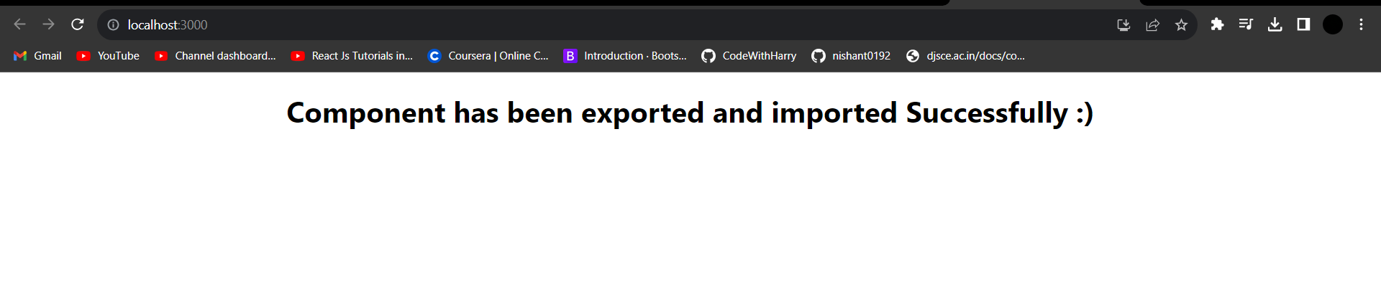

1. **Code:**

import './App.css';

function App() {

  return (

    <div className="App">

      <h1>Importing Css</h1>

      <p>Successfully imported CSS :)</p>

    </div>

  );

}

export default App;

p{

  color: red;

  text-align: center;

  font-size: 4rem;

  font-weight: 900;

}

h1{

  text-align: center;

}

**Output:**

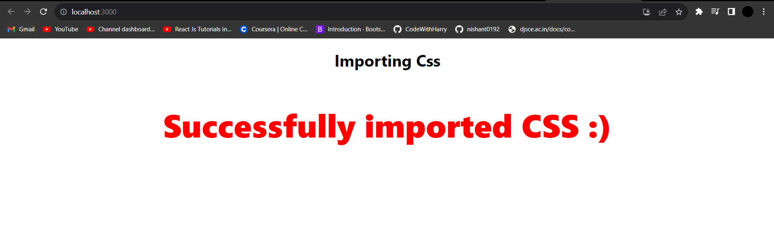

1. **Code:**

import './App.css';

import Greeting from './Greeting';

function App() {

  return (

    <div className="App">

        <Greeting name="Nishant" />

    </div>

  );

}

export default App;

import React from 'react'

function Greeting(props) {

  return (

    <div>

        <h1>Implemented Props Successfully :)</h1>

        <h2 style={{color:"red"}}>Hello {props.name}</h2>

    </div>

  )

}

export default Greeting

**Output:**

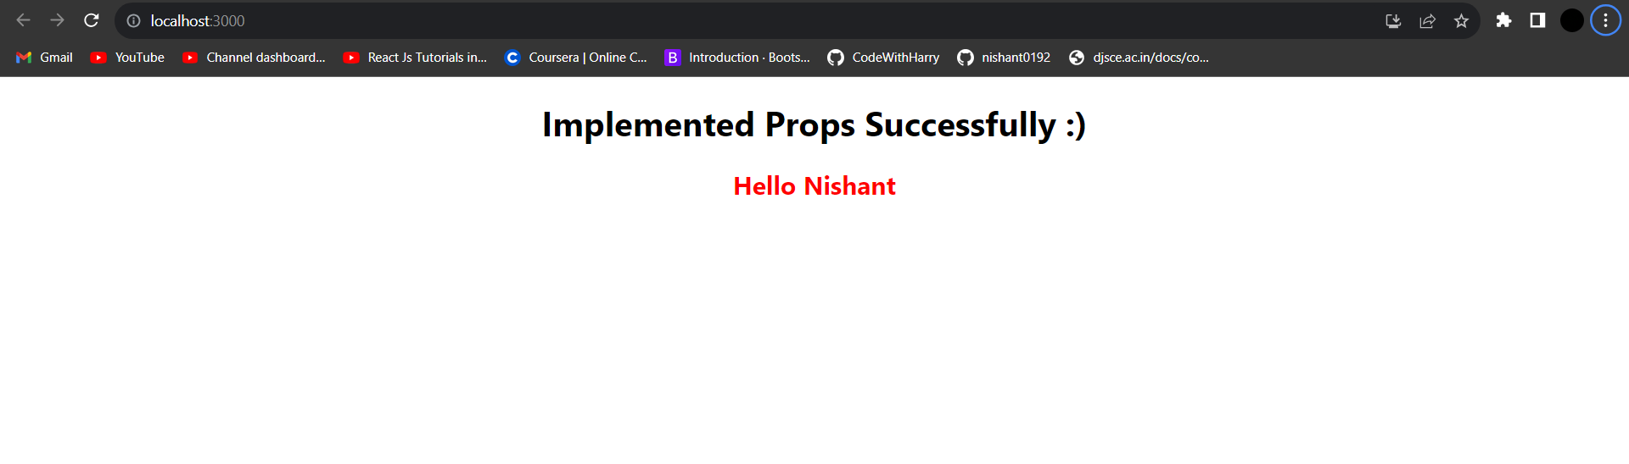

1. **Code:**

import "./App.css";

function App() {

  let count = 0;

  const handleClick = () => {

    count++;

    console.log(`clicked `,count,`times`);

  };

  return (

    <div className="App">

      <h1>Event Raising and Handling done Successfully :)</h1>

      <button onClick={handleClick}>Click Me</button>

    </div>

  );

}

export default App;

**Output:**

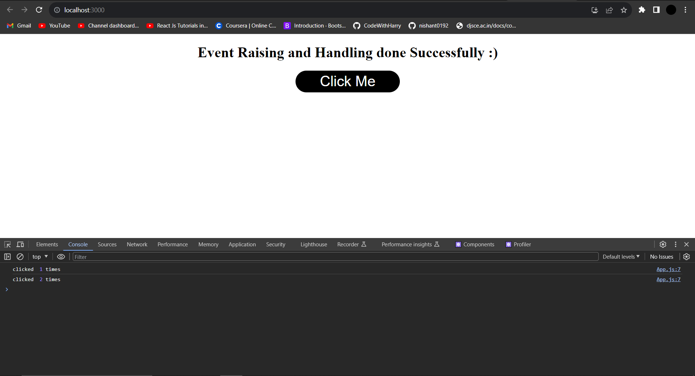

1. **Code:**

import "./App.css";

import React,{useState} from "react"

function App() {

  const [count, setcount] = useState(0)

  return (

    <div className="App">

      <h1>Used UseState Hook Successfully :)</h1>

      <button onClick={()=>setcount(count+1)}>Increment</button>

      <button onClick={()=>setcount(count-1)}>Decrement</button>

      <p>Count: {count}</p>

    </div>

  );

}

export default App;

**Output:**



